Introduction to Proteins and DNA

Proteins

1. The function of a protein is related to its shape. Match each figure with the appropriate description.

- A porin protein provides a channel for a small molecule to diffuse across a cell membrane.
- Collagen gives strength to skin, bones, tendons (which connect muscles to bones), and ligaments (which connect bones in joints).

Most enzymes have a similar overall shape. However, each enzyme has an active site with a unique structure that matches the enzyme’s function.

2. Explain why this enzyme can break down maltose into two molecules of glucose, but it cannot break down collagen into its component amino acids. | 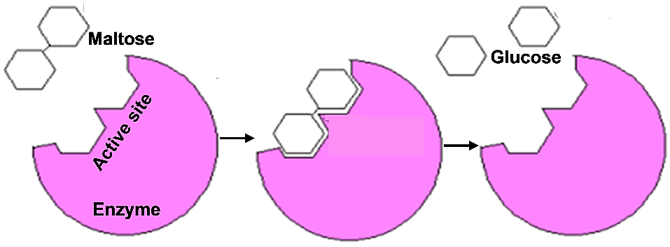

3a. Many proteins move or change shape to carry out their function. In this figure, circle the part of the motor protein that will move next and use an arrow to show how it will move. (If needed, review the video at https://www.youtube.com/watch?v=y-uuk4Pr2i8.)

3b. Describe one way that the shape of the motor protein is
related to its function.

4. List at least three functions of proteins, and give an example of each.

How do genes influence our characteristics?

5. Explain what a gene is. (If needed, review the video “What are DNA and genes?” at https://learn.genetics.utah.edu/content/basics/dna.)

Different people may have different versions of a gene. These different versions of a gene give the instructions to make different versions of a protein. Different versions of a protein can result in different characteristics. This chart shows an example.

Gene in DNA | → | Protein | → | Characteristic
 | → | 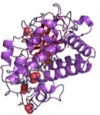 | → | 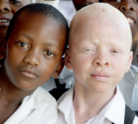
One version of a gene gives instructions to make functional protein enzyme. | → | The functional protein enzyme makes melanin. Melanin is the pigment that gives color to skin and hair. | → | Normal skin and hair color
Another version of this gene gives instructions to make a  non-functional version of this protein enzyme. | → | The non-functional version of this protein enzyme does not make melanin. | → | Albinism (very pale skin and hair)

6a. The first figure above shows that a gene in the DNA is copied to an RNA molecule. What is the function of the RNA molecule? (If needed, review the video “What is DNA and how does it work?” at https://www.statedclearly.com/videos/what-is-dna/.)

6b. Complete this diagram to show how a gene gives the instructions to make a protein. Include the following in your diagram: DNA, gene, RNA, ribosome, amino acids, and protein. | 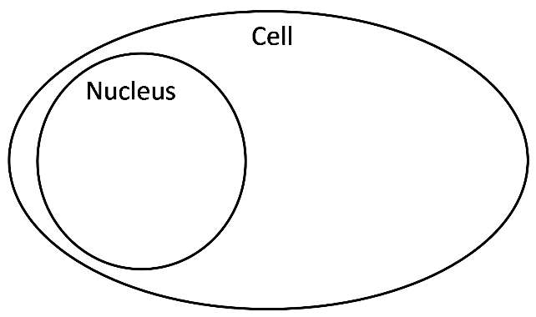

7a. What causes the skin cells of the boys in the photo to produce different versions of the protein enzyme that can make melanin?

7b. Explain how different versions of this protein enzyme can result in albinism vs. normal skin and hair color.

By Dr. Ingrid Waldron, Dept Biology, Univ. Pennsylvania, © 2023. To use this Student Handout, please see the Teacher Notes (with instructional suggestions and biology background) and the PowerPoint at https://serendipstudio.org/exchange/bioactivities/proteins.

